RESOLUTION NO.__________

RE: CERTIFICATE OF APPROPRIATENESS UNDER THE
PROVISIONS OF THE ACT OF THE PENNSYLVANIA
LEGISLATURE 1961, JUNE 13, P.L. 282 (53
SECTION 8004) AND BETHLEHEM ORDINANCE NO.
3952 AS AMENDED.

WHEREAS, it is proposed to install a sign at 129 E. Third Street.

NOW, THEREFORE, BE IT RESOLVED by the Council of the City of Bethlehem that a Certificate of Appropriateness is hereby granted for the work.

Sponsored by: (s)

(s)

ADOPTED BY COUNCIL THIS DAY OF

(s)
President of Council

ATTEST:

(s)
City Clerk

HISTORIC CONSERVATION COMMISSION

CASE # 632– It is proposed to install a sign at 129 E. Third Street.
OWNER/APPLICANT: East Allen Venture, LLC / Nicholas Malitsis

The Commission upon motion by Mr. Cornish seconded by Mr. Lousch adopted the proposal that City Council issue a Certificate of Appropriateness for the proposed work described herein:

- The proposal to install a sign at 129 E. Third Street was represented by Nikos Malitsis.
- The existing sign will be removed and replace with new letters. The sign will read “Greek Meat Guy” in blue 12” PVC letters installed with 1” spacers and pin mounted. The design will match the rendering submitted.
- Vinyl window letters in white, approximately 24’ x 30”, will also be installed as sketched at the meeting. Under the name of the restaurant, Greek Meat Guy will be “Eat in, Take out, Delivery” with phone number. The lettering will be sans-serif in style.

- The motion to approve the proposed work was unanimously approved.

CU: cu
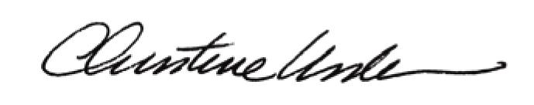

By:

Date of Meeting: November 20, 2017 Title: Historic Officer

